Часть 1

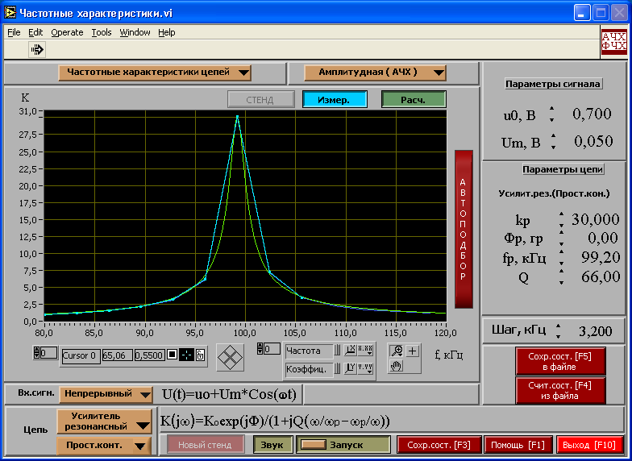

Часть 2

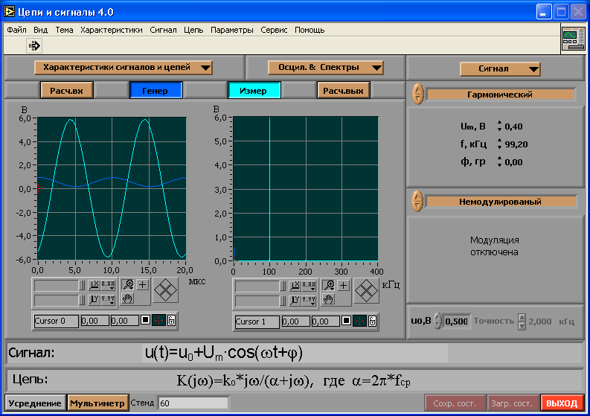

Выход с Iэ

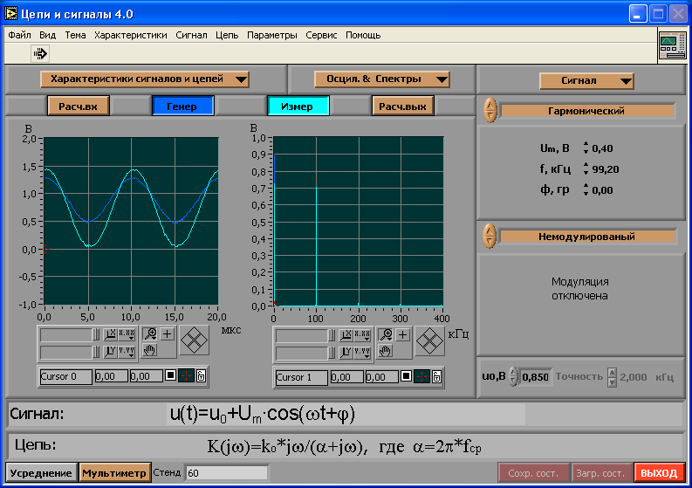

Kp1=V/U=6.4/0.4=16

3 пункт

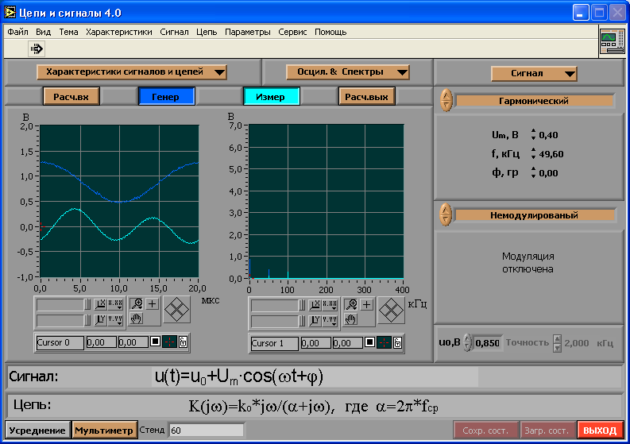

Kp2=V/U=0.4/0.4=1

4 пункт

|  |  |  |  |  |  |  |  |  |  |  |  |  |  |  |  |  |  |
| --- | --- | --- | --- | --- | --- | --- | --- | --- | --- | --- | --- | --- | --- | --- | --- | --- | --- |
| Um ,B | 0.2 | 0.4 | 0.6 | 0.8 | 1 | 1.2 | 1.4 | 1.6 | 1.8 | 2 | 2.2 | 2.4 | 2.6 | 2.8 | 3 | 3.5 | 4 |
| V, B | 4.1 | 6.4 | 6.4 | 6.3 | 6.2 | 6.1 | 5.9 | 5.8 | 5.7 | 5.6 | 5.5 | 5.4 | 5.2 | 5.2 | 5 | 4.7 | 4.4 |